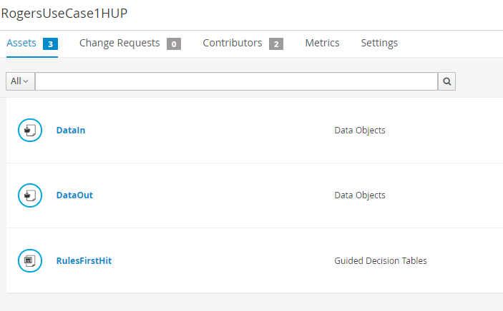

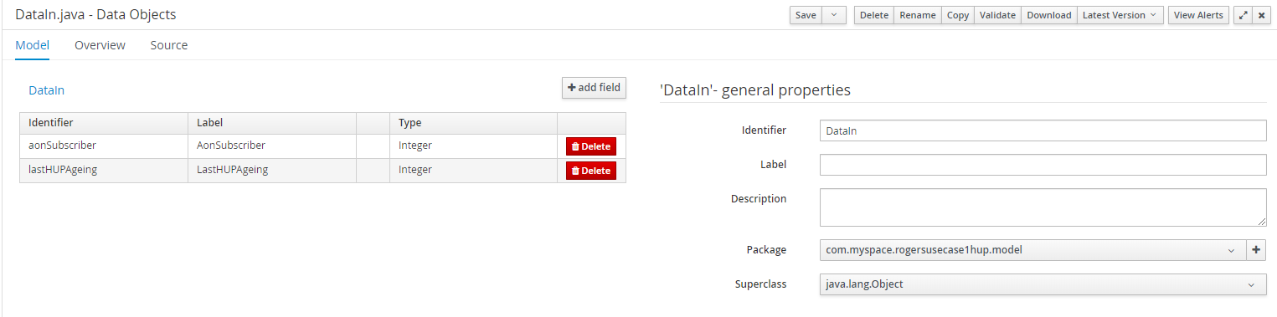

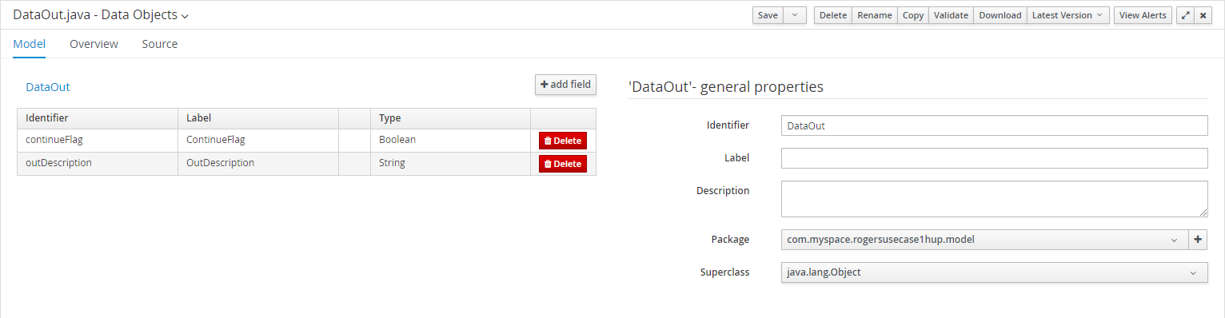

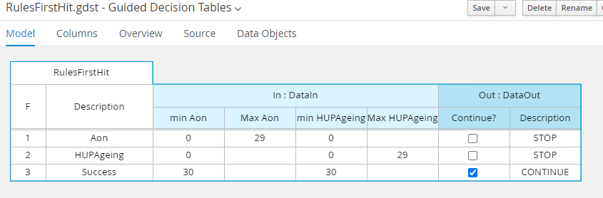
Guided Rules source:
package com.myspace.rogersusecase1hup.model.rules;

import com.myspace.rogersusecase1hup.model.DataIn;
import com.myspace.rogersusecase1hup.model.DataOut;

//from row number: 1
//Aon
rule "Row 1 RulesFirstHit"
activation-group "first-hit-policy-group RulesFirstHit"
dialect "mvel"
when
In : DataIn( aonSubscriber >= 0 , aonSubscriber <= 29 , lastHUPAgeing >= 0 )
then
DataOut Out = new DataOut();
Out.setContinueFlag( false );
Out.setOutDescription( "STOP" );
insert( Out );
end

//from row number: 2
//HUPAgeing
rule "Row 2 RulesFirstHit"
activation-group "first-hit-policy-group RulesFirstHit"
dialect "mvel"
when
In : DataIn( aonSubscriber >= 0 , lastHUPAgeing >= 0 , lastHUPAgeing <= 29 )
then
DataOut Out = new DataOut();
Out.setContinueFlag( false );
Out.setOutDescription( "STOP" );
insert( Out );
end

//from row number: 3
//Success
rule "Row 3 RulesFirstHit"
activation-group "first-hit-policy-group RulesFirstHit"
dialect "mvel"
when
In : DataIn( aonSubscriber >= 30 , lastHUPAgeing >= 30 )
then
DataOut Out = new DataOut();
Out.setContinueFlag( true );
Out.setOutDescription( "CONTINUE" );
insert( Out );
end

