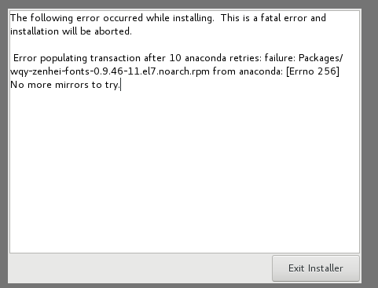
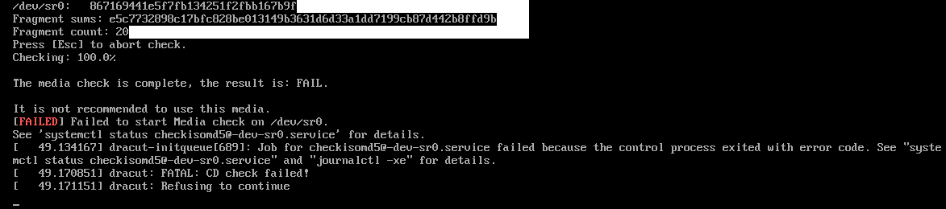
Update: 8/13/2018
Screen clipping taken: 8/13/2018 8:41 AM

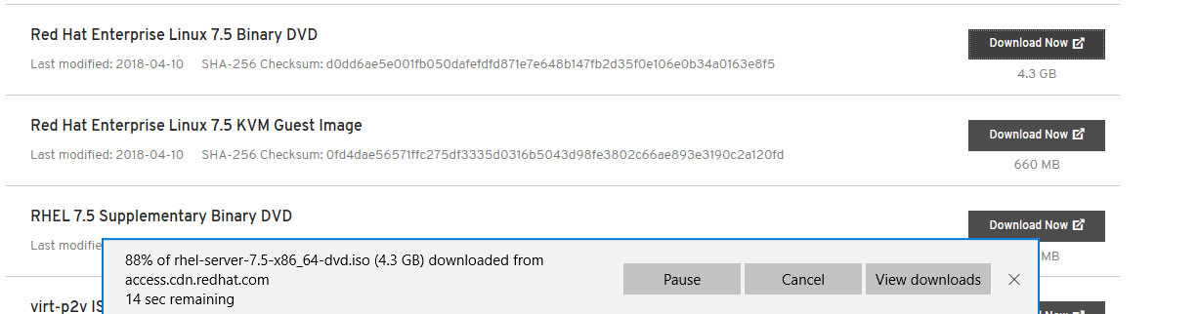

Screen clipping taken: 8/13/2018 8:41 AM

